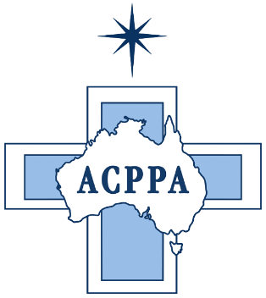

**Australian Catholic Primary Principals’ Association**

*Media Release*

**Australian Catholic Primary Principals Congratulate the Coalition Government**

*May 21, 2019*

The Australian Catholic Primary Principals’ Association has joined with other key educational stakeholders across the country to congratulate the Liberal National Coalition on their win in the recent election.

ACPPA President, Brad Gaynor says, “We wish the Morrison Government well in ensuring future policies affecting education and school students in particular, are thorough in detail and in the best interests of each and every child educated in this great country of ours.”

“Over recent times there has been much speculation and discussion around fair and equitable funding for students in non-government schools and we now hope for stability and consistent action to allow teachers and Principals to be fully and properly supported to educate Australia’s future”.

ACPPA acknowledges and thanks those Ministers who have supported Catholic Education over many years and want to continue to build strong relationships with both current and new Ministers.

We look forward to working closely with the Government in education policy, especially with the Education Minister, to bring long lasting and sustainable change for Catholic schools, and all schools, in their important work.

The Australian Catholic Primary Principals’ Association (ACPPA) represents over 1200 Catholic Primary School Principals across Australia.

**Media Contact**: ACPPA President: Brad Gaynor: 0412 780 668