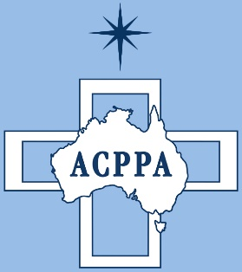

***Australian Catholic Primary Principals’ Association***

***ACPPA endorses call for a timely and independent review of NAPLAN***

The Australian Catholic Primary Principals’ Association (ACPPA) representing over 1200 Catholic primary schools across Australia, agrees with other national Principal’s Associations, in calling for a timely review of NAPLAN and the MySchool website after a decade of implementation.

While NAPLAN is a helpful diagnostic tool for teachers and school leaders to assess the performance of students and schools in literacy and numeracy, a narrow measure of learning which does not encompass creative and critical thinking will do a disservice to schools.

We need to return to the original reason for implementing NAPLAN, which was to give snapshots of progress across school cohorts to better inform policy and school resourcing. Unfortunately, NAPLAN, along with the MySchool website, has become a publicity tool to unfairly compare schools and create a larger than necessary event causing undue stress for students.

ACPPA President Brad Gaynor said, “Comparing schools on a narrow focus limits our ability to have rich conversations with parents about the depth of learning because some parents have become very focussed on NAPLAN results alone.”

“NAPLAN is helpful in providing point in time data to indicate the individual capacity of students, but it does not provide the richness of student learning beyond basic literacy and numeracy skills. Our schools believe that improvement in learning is based on utilising all aspects of teaching combined together to provide the best picture of the learner.

Mr Gaynor, also states, “If we are serious about resourcing schools according to need, then we need to use a sample data collection tool which will address the real needs of students from regional, rural and remote schools and ensure our poorer families in these schools are well catered for in both literacy and numeracy.”

ACPPA believes that NAPLAN is long overdue for a critical review and this review must include teachers and Principals as a part of the process.

Media Contact – Brad Gaynor ACPPA President 0412 780 668